How to install a printer in Windows 7

In the steps below you will need the hostname of the printer you wish to install. You will find the hostnames at http://biostat.mc.vanderbilt.edu/wiki/Main/PrinterHostnames.
Go to Control Panel and click on “View devices and printers”
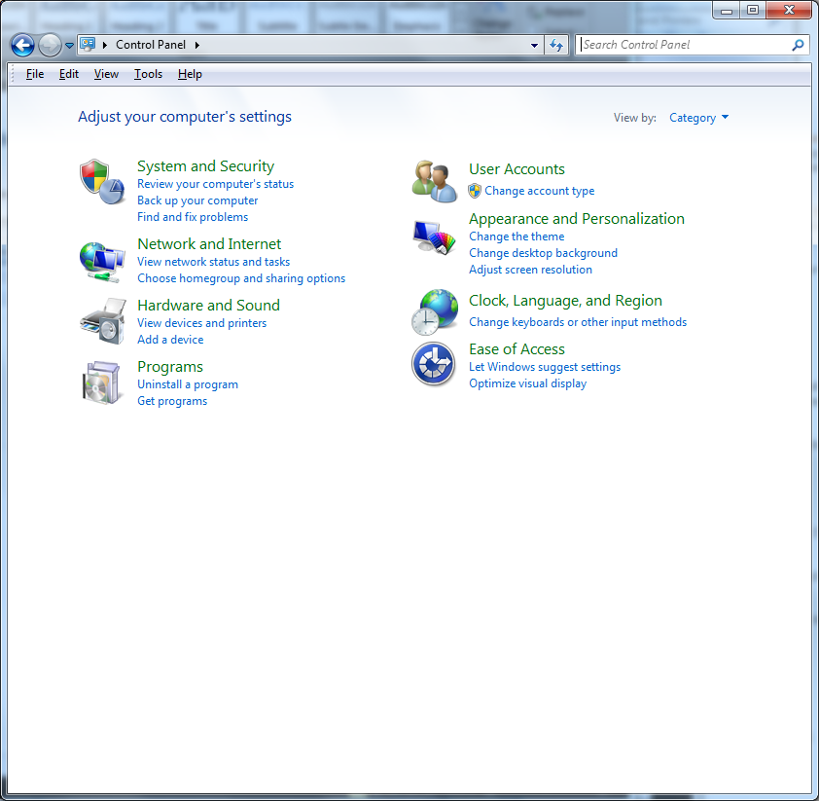
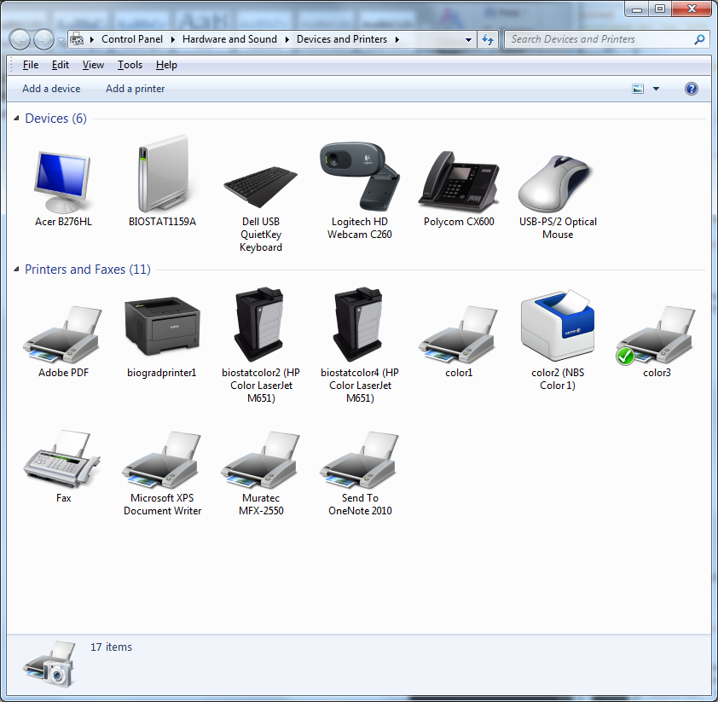
Click on “Add a printer”
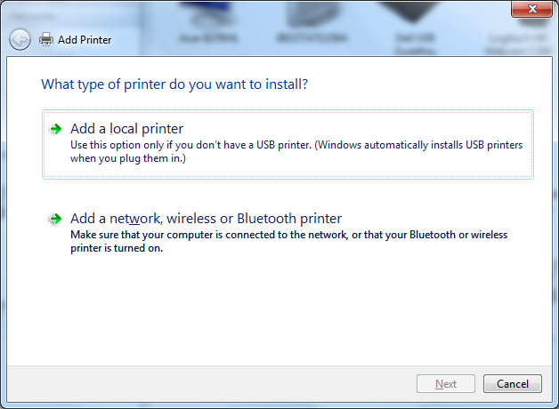
Click on “Add a network, wireless or Bluetooth Printer”
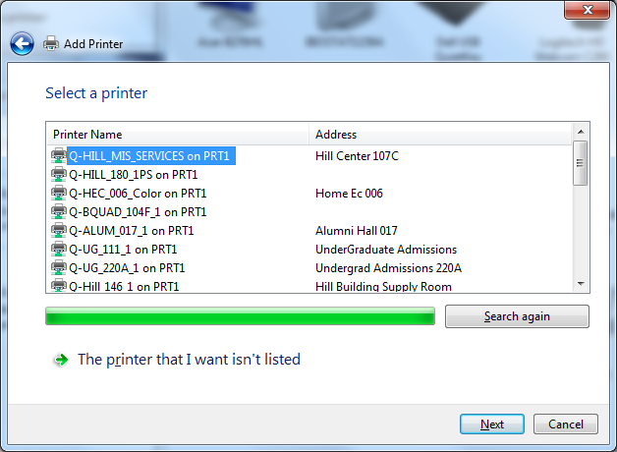
Click on “The printer that I want isn’t listed”
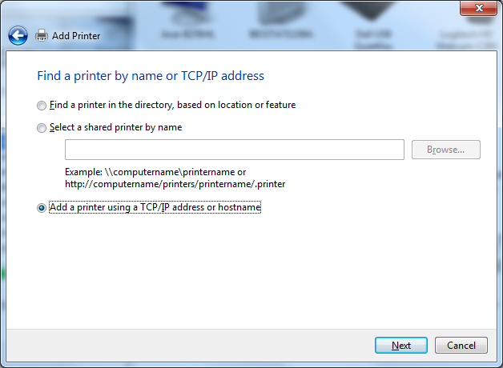
Select “Add a printer using a TCP/IP address or hostname” and click Next
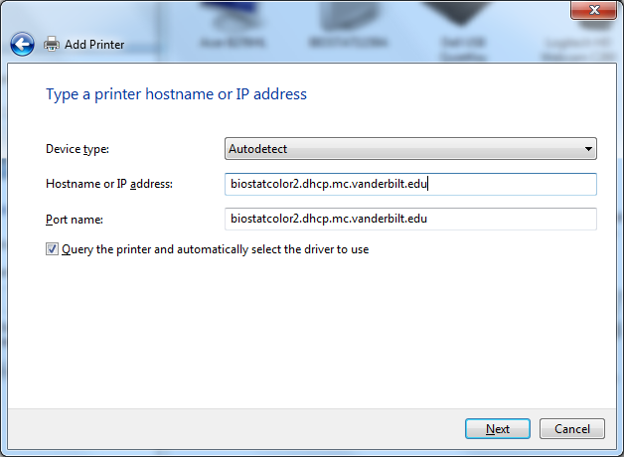
Fill in Device type, Hostname or IP address, and Port name like this. Replace “biostatcolor2.dhcp.mc.vanderbilt.edu” with another printer hostname if appropriate. Port name will default to the correct name as you type in the hostname. Click Next.
Windows will download the software necessary to use the printer. It can take a long time, so be patient.
Eventually it will finish.
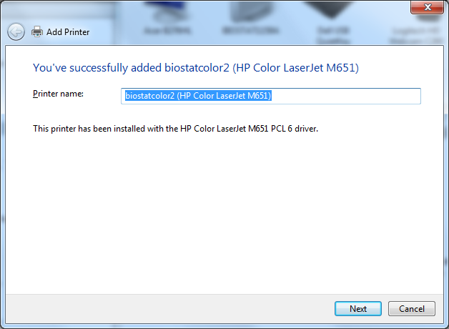
Click Next.
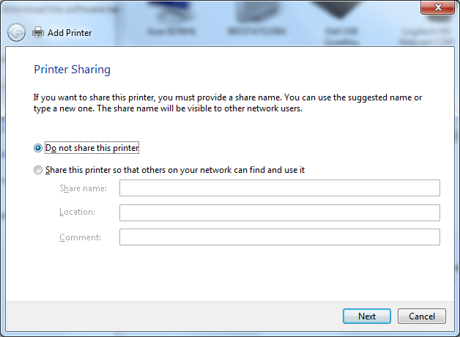
Make sure “Do not share this printer” selected and click Next.
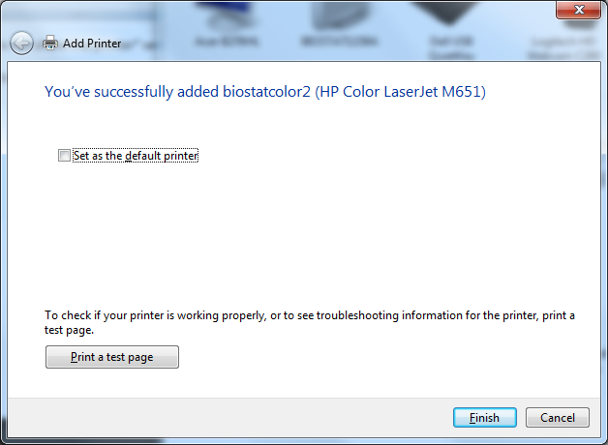
Make this setting as you prefer and click Finish.

