Homework 3

Consider the following directed acyclic graph (DAG):

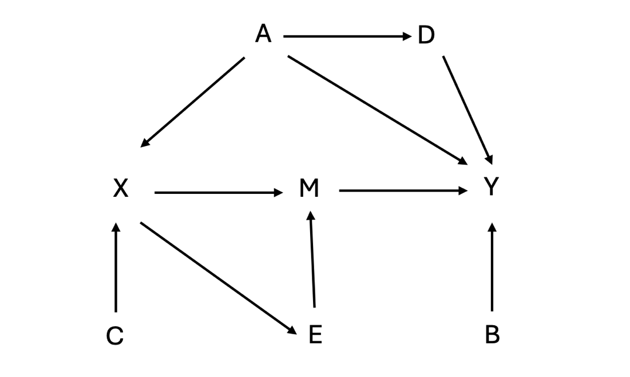

1. Write the joint probability distribution of A, B, C, D, E, M, X, and Y implied by this DAG.

2. What is the minimum set of adjustment variables to identify the (total) causal effect of X on Y?

3. Write an expression (i.e., mathematical formula) for identifying the average treatment effect of X on Y, i.e., E(Y₁-Y₀), where Y_{x} is the potential outcome of Y given X=x?

4. What assumptions are required to identify this average treatment effect?

5. Using the dataset, estimate the average treatment effect of X on Y using g-computation (i.e., “conditional outcome model” or “outcome regression” estimation).

6. Using the dataset, estimate the average treatment effect of X on Y using inverse probability weighting.

7. Using the dataset, estimate the average treatment effect of X on Y using a doubly robust estimator along the lines of Bang and Robins (2005).

8. Compute bootstrap 95% confidence intervals for each of the estimates.

9. Interpret these estimates and discuss. What assumptions are needed for them to be consistent? How does the variance compare for these estimators? Which might we prefer?

