Name: _____________________________ Final (Exam 02)
(Part 1 in-class: open book, notes, laptop, calculators. It is closed internet, wireless, other people.)
(Part 2 take-home solo submission: open everything and everyone worldwide. Cite your sources.)

Instructions: To help you budget your time, questions are marked with *s, with more stars indicating more difficulty. If you can’t solve a question completely, solve it as far as you can. Describe in detail what you could do to solve the problem. Show your work on all problems.
Round final solutions to three decimal places unless specified otherwise.

Special thanks to the authors of the projects that inspired several of these questions!

Question setup: Mary loves Taco Bell and eats there almost every day. She passes three of the franchise restaurants on her way to and from work. She can't tell if any of them are better or worse than the others, so she picks which to eat at haphazardly. One year, she decides to record the quality of her dining experiences. The data is below.

image used without permission | Dining Experience | Restaurant  A | Restaurant  B | Restaurant  C
 | Truly  Awesome | 92 | 88 | 80
 | Just  Excellent | 8 | 12 | 20
 | Total | 100 | 100 | 100

*Q1-4pts) In mathematical terms, using Greek letters to represent parameters, what is the null hypothesis for a Chi-squared test of this data?

*Q2-4pts) At a 5% significance level, what would be the rejection region for this test?

*Q3-7pts) Under the null hypothesis, what is the expected number of "truly awesome" dining experiences for restaurant A, i.e. when calculating the Chi-square test statistic, what would you use for the expected count “E” for restaurant A?

*Q4-4pts) Each cell of the 2x3 table contributes a certain amount to the Chi-squared test statistic. If not using a continuity correction, how much would the first cell (truly awesome for restaurant A) contribute to the Chi-squared test statistic?

*Q5-4pts) Running the following two commands in R yields a Chi-squared statistic = 6.462.
x <- matrix( c(92,8,88,12,80,20), nrow=2 )
chisq.test(x, correct=F)
Based only on the questions and information presented so far in this exam, write a conclusion for the hypothesis test being performed using a 5% significance level. Discuss the results including any practical decisions Mary can make based on this analysis. (For sake of time, do not include any confidence intervals in your conclusion.)

*Q6-2pts) Comment on the appropriateness of the test being used and how it is likely to compare to a Chi-squared test with a continuity correction and to Fisher's exact test.
*Q7-4pts) Referring to the data in question 1, calculate the odds ratio for a truly awesome dining experience in restaurant A vs. restaurant B.

**Q8-8pts) Calculate a 95% confidence interval for the relative risk of a truly awesome dining experience in restaurant A vs. restaurant B.

**Q9-6pts) Calculate an asymptotically Normal (Wald) 95% confidence interval for the risk difference of a truly awesome dining experience in restaurant A vs. restaurant B.

*Q10-3pts) Using the R package epitools, I calculated 95% CI's for the odds ratio for a truly awesome dining experience for each pairing of restaurants. Based on the results below, state what practical conclusions, if any, can Mary draw from the data? The code and results follow.
library(epitools)
x <- matrix( c(92,8,88,12,80,20), nrow=2 )
round( epitab(t(x))$tab, 2 )
y <- matrix( c(88,12,80,20), nrow=2 )
round( epitab(t(y))$tab, 2 )
*Results*
A vs B: (0.61, 4.02)
A vs C: (1.20, 6.88)
B vs C: (0.84, 3.99)

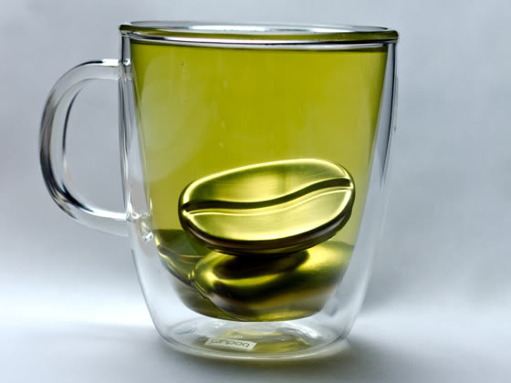 | Question setup: Coffee Joulies™ are a stainless steel shell filled with a non-toxic paraffin wax. Placed in a very hot beverage, e.g. coffee or tea, they serve to increase the amount of time the drink stays within the most desirable range of temperatures for consumption.  Jerry pours 10 cups of piping hot coffee, randomly selects 5 of them, and places a Coffee Joulie in each of those 5 cups. He then measures the times the coffee spends in the optimal drinking temperature range for each cup. The data, reported in minutes, follow.

With Joulies: 9.9, 11.0, 12.0, 12.6, 12.7 mean (sample sd): 11.64 (1.18)
Without Joulies: 8.3, 9.3, 9.7, 10.4, 11.2 mean (sample sd): 9.78 (1.10)

Here is one analysis in R:
t.test( WithJoulies, WithoutJoulies, var.equal=F )
Welch Two Sample t-test
t = 2.574, df = 7.955, p-value = 0.033

*Q11-2pts) In standard mathematical notation, using Greek letters for parameters, write the null and alternative hypotheses for the test performed above.

*Q12-8pts) What assumptions does the test performed above require to be valid?

*Q13-2pts) Write a conclusion for the hypothesis test being performed using a 5% significance level.

*Q14-2pts) In standard mathematical notation or described in English, write the null and alternative hypothesis for a Wilcoxon-Mann-Whitney rank sum test on the Coffee Joulies data.

**Q15-7pts) Calculate the rank sum test statistic for the Wilcoxon-Mann-Whitney rank sum test. Remember to show all work.

**Q16-7pts) Calculate a two-sided p-value for the Wilcoxon-Mann-Whitney rank sum test. Remember to show all work.

*Q17-2pts) Write a conclusion for the Wilcoxon-Mann-Whitney test using a 5% significance level.

***Q18-12pts) In this dataset, the t-test and Wilcoxon-Mann-Whitney test disagree when using a 5% significance level. One could argue that the Wilcoxon-Mann-Whitney is being overly conservative by taking the ranks of the data. After all, there are no blatant outliers in this dataset. On the other hand, one could argue the t-test is relying too heavily on assumptions to justify the p-value it returns. It is possible to evaluate the t-test's test statistic assuming nothing other than the fact that the Coffee Joulies were placed randomly into five cups. If the null hypothesis is true, the Joulies don't do anything. So we could look at every way the experiment could have turned out if the null were true by looking at every way the Joulies could have been placed and calculating the respective t-test test statistic for each case. Use this logic to calculate a two-sided p-value for the t-test's test statistic assuming nothing other than the fact that the Coffee Joulies were placed randomly into five cups.

***Q19-12pts) The 1/8th support interval for a proportion is based on a different statistical paradigm than our 95% confidence intervals. However, we can still examine the true coverage rates of 1/8th support intervals. Compare and contrast the performance of the 1/8th support interval for a proportion with that of the 95% Wilson Interval. (Hint: remember the work you did earlier in the semester exploring the true coverage rate of various confidence interval methods for proportions.)

